Intelligent CATBoost-Based Automated Stroke Prediction with Explainable AI for Early Detection and Intervention

1. INTRODUCTION:
The incidence of stroke has been increasing globally, and it is now considered one of the leading causes of death and disability. Early intervention is crucial in preventing long term disability and mortality associated with stroke. Traditional methods of predicting stroke risk, however, are often time-consuming and prone to errors. Recently, machine learning algorithms have shown great promise in accurately predicting stroke risk based on various clinical risk factors. By leveraging these algorithms, clinicians can identify high-risk patients and intervene early, potentially reducing the number of stroke-related complications and improving patient outcomes. Additionally, there is a growing need for transparency and explainability in machine learning models in healthcare. The use of an interpretable machine learning model can provide clinicians with valuable insights into the factors that contribute to a patient's stroke risk, thereby aiding in treatment decisions. The World Stroke Organisation estimates that 13 million people worldwide experience a stroke each year, leading to 5.5 million fatalities [1]. Stroke affects all aspects of a patient's life, including their family, social environment, and work, and is one of the top causes of mortality and disability in the world [1, 2]. A common misconception is that certain groups of people, such as the elderly or those with underlying illnesses, are the only ones who are affected by stroke. In reality, anybody can be impacted, regardless of age, gender, or physical health [1, 2]. A stroke is a rapid, serious disruption in blood flow to the brain that deprives brain cells of oxygen. It comes in ischemic and haemorrhagic varieties. Moderate to severe strokes can cause permanent or temporary damage, depending on their severity. Haemorrhagic strokes are uncommon; however, they are brought on by the rupture of a blood vessel in the brain. The most common type of stroke happens when an artery is blocked or narrows, preventing blood flow to the brain [3, 4]. Age over 55, prior stroke or TIA, arrhythmia, high blood pressure, carotid stenosis from atherosclerosis, smoking, high blood cholesterol, diabetes, obesity, inactivity, estrogenic therapy, blood clotting disorders, cocaine or amphetamine use, and heart issues like infarction and cardiac arrest are all risk factors for stroke [5-7]. Strokes can occur suddenly, and their symptoms might vary and be unanticipated. The main symptoms of a stroke include paralysis on one side of the body, numbness in the face, arms, or legs, difficulty speaking or walking, dizziness, blurred vision, headache, vomiting, drooping mouth, and, in severe cases, loss of consciousness and coma. These sensations may come on suddenly or gradually, and in certain rare cases, they may cause you to become aware [8–10]. Stroke can impact both men and women, lowering their quality of life and putting a load on public health resources. The scientific community prioritizes building models for predicting strokes to avoid them, and AI plays a critical role in this endeavour because it is extensively employed for disease prevention. Several research has been carried out to construct models for stroke diagnosis [11-13], predict treatment results and patient responses, and design individualized rehabilitation techniques [14-16]. Arslan et al. [17], for example, suggested a data mining system to predict ischemic strokes utilizing data from 80 ischemic stroke patients and 112 healthy persons, with the Support Vector Machine (SVM) classifier achieving the greatest accuracy of 97.89% and AUC of 97.83%. The study also looked at how different factors affected identifying the key risk factors for ischemic stroke.
1.1 Objective of the project:
Stroke is a dangerous medical disorder that occurs when blood flow to the brain is disrupted, resulting in neurological impairment. It is a big worldwide threat with serious health and economic implications. To solve this, researchers are developing automated stroke prediction algorithms, which would allow for early intervention and perhaps save lives. The number of people at risk for stroke is growing as the population ages, making precise and effective prediction systems increasingly critical. The goal of this study was study aimed to achieve three objectives: (i) to create a trustworthy machine learning model to predict stroke disease, (ii) to address the severe class imbalance issue that results from the stroke patients' class being substantially smaller than the healthy class, and (iii) by using Mutual Information Score, Chi-Square Score, and ANOVA test, find the import feature(iv) to interpret the model output to gain a better comprehension of the decision-making process (v) balancing the dataset from the ratio of 19: 1 for No Stroke: Stroke to equal ratio using SMOTE Analysis (vi) Propose an End-to-End smart healthcare system through an android application. In a comparison examination with six well-known classifiers, the effectiveness of the proposed ML technique was explored in terms of metrics relating to both generalization capability and prediction accuracy. To give insight into the black-box machine learning models, we also studied two kinds of explainable techniques, namely SHAP and LIME, in this study. SHAP (Shapley Additive Explanations) and LIME (Local Interpretable Model-agnostic Explanations) are well-established and reliable approaches for explaining model decision-making, particularly in the medical industry. The findings of the experiment revealed that more complicated models outperformed simpler ones, with the top model obtaining almost 91% accuracy and the other models achieving 83-91% accuracy. The proposed framework, which includes global and local explainable methodologies, can aid in standardizing complicated models and gaining insight into their decision-making, which can enhance stroke care and treatment.
2. LITERATURESURVEY:

World Stroke Organization (WSO): Global Stroke Fact Sheet 2022

Stroke remains the second-leading cause of death and the third-leading cause of death and disability combined (as expressed by disability-adjusted life-years lost - DALYs) in the world. The estimated global cost of stroke is over US$721 billion (0.66% of the global GDP). From 1990 to 2019, the burden (in terms of the absolute number of cases) increased substantially (70.0% increase in incident strokes, 43.0% deaths from stroke, 102.0% prevalent strokes, and 143.0% DALYs), with the bulk of the global stroke burden (86.0% of deaths and 89.0% of DALYs) residing in lower-income and lower-middle-income countries (LMIC). This World Stroke Organisation (WSO) Global Stroke Fact Sheet 2022 provides the most updated information that can be used to inform communication with all internal and external stakeholders; all statistics have been reviewed and approved for use by the WSO Executive Committee as well as leaders from the Global Burden of Disease research group.

The relationship between social support and participation in stroke: A systematic review
Background: The incidence of cerebrovascular accidents with its devastating effects on individuals is increasing. Post-stroke, restrictions in participation are common and social support could have an influence on this. Social support provided to individuals post-stroke is vital, but the relationship between social support and participation is not well understood.
Objectives: This review aimed to systematically determine the relationship between social support and participation post-stroke, based on the literature available.
Method: Ebscohost, Science Direct, Biomed Central, Cochrane Library, Google Scholar, Pedro Central and Wiley Online were the electronic databases searched between 2001 and 2016. Articles were deemed to be eligible if they met the inclusion criteria and successfully underwent scrutiny to determine their relevance and methodological quality, using tools from the Critical Appraisal Skills Programme and Milton Keynes Primary Trust. A narrative synthesis method was used to analyse the included studies.
Results: A total of 54 articles were identified after screening, and six articles were deemed eligible for inclusion. The articles consisted of cross-sectional, qualitative and cohort studies. Articles showed distinct, significant relationships between social support and participation where the quality and quantity of social support were important. High levels of social support had a positive influence on participation, social and leisure activities, as well as returning to work post-stroke.
Conclusion: A positive relationship exists between social support and participation post-stroke. Health professionals need to include social support interventions when attempting to manage the individual with stroke holistically, as this will have positive effects on participation.

Global Burden of Stroke

Stroke is the second leading cause of death and a major cause of disability worldwide. Its incidence is increasing because the population ages. In addition, more young people are affected by stroke in low- and middle-income countries. Ischemic stroke is more frequent but haemorrhagic stroke is responsible for more deaths and disability-adjusted life-years lost. Incidence and mortality of stroke differ between countries, geographical regions, and ethnic groups. In high-income countries mainly, improvements in prevention, acute treatment, and neurorehabilitation have led to a substantial decrease in the burden of stroke over the past 30 years. This article reviews the epidemiological and clinical data concerning stroke incidence and burden around the globe.

Blood Biomarkers to Differentiate Ischemic and Hemorrhagic Strokes
Objective: To validate a panel of blood biomarkers to differentiate between ischemic stroke (IS) and intracerebral hemorrhage (ICH) in patients with suspected stroke.
Methods: Patients with suspected stroke admitted within 4.5 hours after onset were enrolled. Blood samples were collected at hospital admission. Glial fibrillary acid protein (GFAP), retinol binding protein 4 (RBP-4), N-terminal proB-type natriuretic peptide (NT-proBNP), and endostatin were measured by immunoassays. Cutoff points were obtained for 100% specificity for IS. A high-sensitivity assay to measure GFAP and rapid point-of-care tests (POCTs) to measure RBP-4 and NT-proBNP were used in subsets of patients. Biomarker panels were evaluated in another cohort of 62 stroke mimics.
Results: A total of 189 patients (154 IS and 35 ICH) were enrolled. Patients with IS had higher RBP-4, NT-proBNP, and endostatin and lower GFAP levels than patients with ICH. The best biomarker combination for the identification of IS was RBP-4+NT-proBNP, which was able to identify 29.7% of patients with IS with 100% specificity. In the subset of patients for whom GFAP was measured with the high-sensitivity assay, RBP-4, NT-proBNP, and GFAP identified 51.5% of patients with IS with 100% specificity. When stroke mimics were included, specificities were reduced to 98.4 and 96.8%, respectively. POCTs of RBP-4 and NT-proBNP showed results similar results to those of conventional ELISAs.
Conclusions: A biomarker panel including RBP-4, NT-proBNP, and GFAP provided moderate but potentially useful sensitivity rates at 100% specificity for IS diagnosis. If confirmed in future studies, this strategy might allow prehospital treatment in selected patients.
Classification of evidence: This study provides Class I evidence that a biomarker panel including RBP-4, NT-proBNP, and GFAP distinguishes IS from ICH with moderate accuracy.

Prevalence and risk factors of stroke in the elderly in Northern China: data from the National Stroke Screening Survey

Background: The overall global burden of stroke is considerable and increasing. In China, stroke is the leading cause of death and disability.
Methods: For this study, we used data from the National Stroke Screening Survey in 2012 and the 2010 Chinese population from sixth National Census of Populations to calculate a standardized (by age, gender, and education) stroke prevalence. Prevalence, risk factors, and management of stroke were compared by gender, age, and site.
Findings: The standardized prevalence rate of survival stroke patients in study population aged 60 and older was 4.94% in total. Hypertension was the most prevalent risk factor for stroke. Compared to men, women were more likely to have diabetes, obesity, elevated low-density lipoprotein cholesterol (LDL-C), and atrial fibrillation (P < 0.05). Men were far more likely to drink and smoke than women (P < 0.05). The rates of diabetes and atrial fibrillation were substantially higher in urban than those in rural stroke survivors (P < 0.05). Rural stroke survivors exhibited higher rates of smoking and alcohol consumption than urban stroke survivors (P < 0.05).
Interpretation: The stroke prevalence in China is in line with median worldwide stroke prevalence. Traditional risk factors remain highly prevalent in stroke survivors, among which hypertension was the most common. Stroke prevalence rates and risk factors varied by age, sex, and sociogeological factors.

Hypertension and Diabetes Mellitus as a Predictive Risk Factors for Stroke
Background Stroke is becoming a major challenge in healthcare systems, and this has necessitated the study of the various risk factors. As the number of people with hypertension, diabetes mellitus and obesity increases, the problem is expected to worsen. This review paper evaluates what can be done to eliminate or reduce the risk of stroke. Objective The aim of the research is to evaluate the risk factors for stroke. The paper also aims to understand how these risks can be handled to avoid incidences of stroke. Method Published clinical trials of stroke risk factors studies were recognised by a search of EMBASE and MEDLINE databases with keywords hypertension, blood pressure, diabetes mellitus, stroke or cardiovascular disease, or prospective study, and meta-analysis. Results The findings of this review are that the prevention of stroke starts with identifying risk factors for stroke, most of the patients diagnosed with stroke have various risk factors. Consequently, it is a very significant to identify all the risk factors for stroke as well as to teach the patient how to dominate them. Conclusion after summarising all the studies mentioned in the paper, it can be established that hypertension and diabetes mellitus are a stroke risk factors and correlated in patients with atherosclerosis. Keywords: Hypertension; diabetes mellitus; stroke; risk factors; lifestyle

Stroke Risk Factors, Genetics, and Prevention

Stroke is a heterogeneous syndrome, and determining risk factors and treatment depends on the specific pathogenesis of stroke. Risk factors for stroke can be categorized as modifiable and nonmodifiable. Age, sex, and race/ethnicity are nonmodifiable risk factors for both ischemic and hemorrhagic stroke, while hypertension, smoking, diet, and physical inactivity are among some of the more commonly reported modifiable risk factors. More recently described risk factors and triggers of stroke include inflammatory disorders, infection, pollution, and cardiac atrial disorders independent of atrial fibrillation. Single-gene disorders may cause rare, hereditary disorders for which stroke is a primary manifestation. Recent research also suggests that common and rare genetic polymorphisms can influence risk of more common causes of stroke, due to both other risk factors and specific stroke mechanisms, such as atrial fibrillation. Genetic factors, particularly those with environmental interactions, may be more modifiable than previously recognized. Stroke prevention has generally focused on modifiable risk factors. Lifestyle and behavioral modification, such as dietary changes or smoking cessation, not only reduces stroke risk, but also reduces the risk of other cardiovascular diseases. Other prevention strategies include identifying and treating medical conditions, such as hypertension and diabetes, that increase stroke risk. Recent research into risk factors and genetics of stroke has not only identified those at risk for stroke but also identified ways to target at-risk populations for stroke prevention.

Stroke symptoms and the decision to call for an ambulance
Background and purpose: Few acute stroke patients are treated with alteplase, partly because of significant prehospital delays after symptom onset. The aim of this study was to determine among ambulance-transported stroke patients factors associated with stroke recognition and factors associated with a call for ambulance assistance within 1 hour from symptom onset.
Methods: For 6 months in 2004, all ambulance-transported stroke or transient ischemic attack patients arriving from a geographically defined region in Melbourne (Australia) to 1 of 3 hospital emergency departments were assessed. Tapes of the call for ambulance assistance were analyzed and the patient and the caller were interviewed.
Results: One hundred ninety-eight patients were included in the study. Stroke was reported as the problem in 44% of ambulance calls. Unprompted stroke recognition was independently associated with facial droop (P=0.015) and a history of stroke or transient ischemic attack (P<0.001). More than half of the calls for ambulance assistance were made within 1 hour from symptom onset and only 43% of these callers spontaneously identified the problem as "stroke." Factors independently associated with a call within 1 hour were: speech problems (P=0.009), caller family history of stroke (P=0.017), and the patient was not alone at symptom onset (P=0.018).
Conclusions: Stroke was reported as the problem (unprompted) by <50% of callers. Fewer than half the calls were made within 1 hour from symptom onset. Interventions are needed to more strongly link stroke recognition to immediate action and increase the number of stroke patients eligible for acute treatment.

Response to symptoms of stroke in the UK: a systematic review

Background
The English National Stroke Strategy suggests that there is a need to improve the response of patients and witnesses to the symptoms of acute stroke to increase rapid access to specialist care. We wished to review the evidence base regarding the knowledge, attitudes and behaviours of stroke patients, witnesses and the public to the symptoms of stroke and the need for an urgent response at the onset of symptoms.

Methods
We conducted a systematic review of UK articles reporting empirical research on a) awareness of and response to the symptoms of acute stroke or TIA, and b) beliefs and attitudes about diagnosis, early treatment and consequences of acute stroke or TIA. Nine electronic databases were searched using a robust search strategy. Citations and abstracts were screened independently by two reviewers. Data were extracted by two researchers independently using agreed criteria.

Results
11 studies out of 7144 citations met the inclusion criteria. Methods of data collection included: postal survey (n = 2); interview survey (n = 6); review of hospital documentation (n = 2) and qualitative interviews (n = 1). Limited data reveal a good level of knowledge of the two commonest stroke symptoms (unilateral weakness and speech disturbance), and of the need for an emergency response among the general public and at risk patients. Despite this, less than half of patients recognised they had suffered a stroke. Symptom recognition did not reduce time to presentation. For the majority, the first point of contact for medical assistance was a general practitioner.

Conclusions
There is an assumption that, in the UK, public knowledge of the symptoms of stroke and of the need for an emergency response is lacking, but there is little published research to support this. Public awareness raising campaigns to improve response to the symptoms of stroke therefore may not produce an increase in desired behaviours. Further research is needed to understand why people who experience or witness stroke symptoms frequently do not call emergency services.

The differential diagnosis of suspected stroke: a systematic review

Background: We aimed to determine the proportion of patients who had suffered a stroke and compare this to those patients with suspected stroke, and the range of differential diagnosis for suspected stroke.
Methods: We searched for prospective studies of suspected stroke in electronic databases and our personal files. We undertook a meta-analysis of these studies, aimed at determining the proportions of patients with confirmed stroke in different settings.
Results: We identified 29 studies involving 8,839 patients: 13 studies were from emergency departments, five from stroke units or transient ischaemic attack (TIA) clinics, three from primary care, three from ambulance services and five were unspecified. About three-quarters (74% [95% confidence interval (CI): 66 to 83%]) of patients had a diagnosis of stroke, though there was significant heterogeneity in this estimate. The five most frequent non-stroke diagnoses were seizure, syncope, sepsis, migraine and brain tumours.
Conclusion: Patients who had not had a stroke accounted for a significant proportion of people referred to stroke services. Expertise in the differential diagnoses of stroke is needed in order to manage the patients at the point of referral.

3. SYSTEM ANALYSIS
3.1 Existing System
In Existing Stroke often causes due to blood flow stop to brain and this is one of the deadly diseases. Patient life can be saved and stroke can be avoided by timely and accurate detection. Existing detection technique requires heavy resources and they make time for prediction. To overcome from this problem many machine learning algorithms were introduced as they are very accurate in medical diseases prediction but existing techniques were suffering from data leakage such as improper handling or missing values, improper categorical data calculation etc. No existing techniques were employing any Explainable model (XAI) which can show which features are helping most in detecting stroke so doctor can give priority on such features for faster recovery. These explainable features can be Smoking, Age, BMI and may be other features.

DISADVANTAGE:
- Accuracy Less
- More Time Taking
3.2 Proposed System
In propose work author is employing different processing techniques such as Removing missing values, Imbalance data handling using SMOTE and relevant features selection using CHI2 algorithm. All these processed features will get trained on 6 different algorithms such as Random Forest, KNN, SVM, Logistic Regression, XGBOOST and Naive Bayes. In all algorithm Random Forest is giving high accuracy and each algorithm performance is evaluated in terms of accuracy, precision, recall and FSCORE.
ADVANTAGE:
- Accuracy more.
- Less Time Taking.
3.3. PROCESS MODEL USED WITH JUSTIFICATION
SDLC (Umbrella Model):
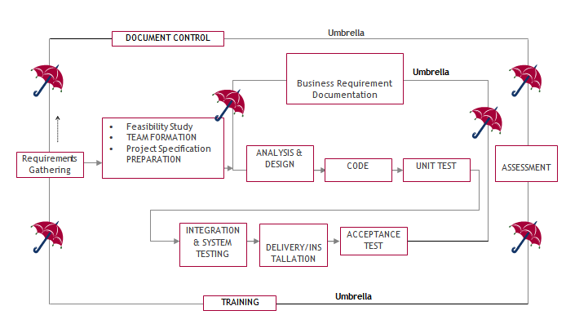
The requirements gathering process takes as its input SDLC is nothing but Software Development Life Cycle. It is a standard which is used by software industry to develop good software.
Stages in SDLC:
- Requirement Gathering
- Analysis
- Designing
- Coding
- Testing
- Maintenance
Requirements Gathering stage:
the goals identified in the high-level requirements section of the project plan. Each goal will be refined into a set of one or more requirements. These requirements define the major functions of the intended application, define operational data areas and reference data areas, and define the initial data entities. Major functions include critical processes to be managed, as well as mission critical inputs, outputs and reports. A user class hierarchy is developed and associated with these major functions, data areas, and data entities. Each of these definitions is termed a Requirement. Requirements are identified by unique requirement identifiers and, at minimum, contain a requirement title and textual description.
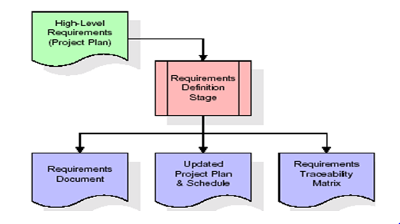

These requirements are fully described in the primary deliverables for this stage: the Requirements Document and the Requirements Traceability Matrix (RTM). The requirements document contains complete descriptions of each requirement, including diagrams and references to external documents as necessary. Note that detailed listings of database tables and fields are not included in the requirements document.
The title of each requirement is also placed into the first version of the RTM, along with the title of each goal from the project plan. The purpose of the RTM is to show that the product components developed during each stage of the software development lifecycle are formally connected to the components developed in prior stages.
In the requirements stage, the RTM consists of a list of high-level requirements, or goals, by title, with a listing of associated requirements for each goal, listed by requirement title. In this hierarchical listing, the RTM shows that each requirement developed during this stage is formally linked to a specific product goal. In this format, each requirement can be traced to a specific product goal, hence the term requirements traceability.
The outputs of the requirements definition stage include the requirements document, the RTM, and an updated project plan.
- Feasibility study is all about identification of problems in a project.
- No. of staff required to handle a project is represented as Team Formation, in this case only modules are individual tasks will be assigned to employees who are working for that project.
- Project Specifications are all about representing of various possible inputs submitting to the server and corresponding outputs along with reports maintained by administrator.
Analysis Stage:
The planning stage establishes a bird's eye view of the intended software product, and uses this to establish the basic project structure, evaluate feasibility and risks associated with the project, and describe appropriate management and technical approaches.
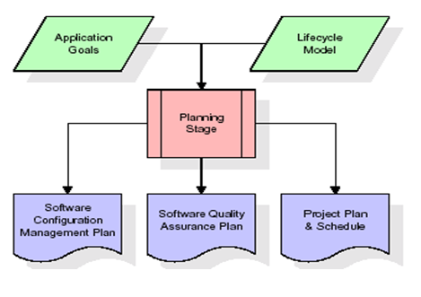

The most critical section of the project plan is a listing of high-level product requirements, also referred to as goals. All of the software product requirements to be developed during the requirements definition stage flow from one or more of these goals. The minimum information for each goal consists of a title and textual description, although additional information and references to external documents may be included. The outputs of the project planning stage are the configuration management plan, the quality assurance plan, and the project plan and schedule, with a detailed listing of scheduled activities for the upcoming Requirements stage, and high level estimates of effort for the out stages.
Designing Stage:
The design stage takes as its initial input the requirements identified in the approved requirements document. For each requirement, a set of one or more design elements will be produced as a result of interviews, workshops, and/or prototype efforts. Design elements describe the desired software features in detail, and generally include functional hierarchy diagrams, screen layout diagrams, tables of business rules, business process diagrams, pseudo code, and a complete entity-relationship diagram with a full data dictionary. These design elements are intended to describe the software in sufficient detail that skilled programmers may develop the software with minimal additional input.
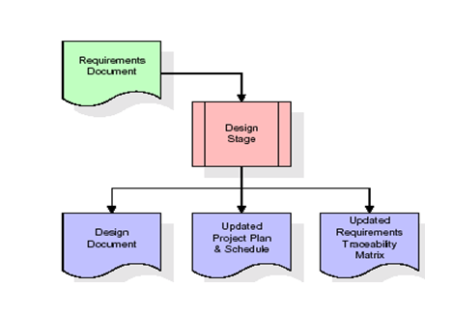
When the design document is finalized and accepted, the RTM is updated to show that each design element is formally associated with a specific requirement. The outputs of the design stage are the design document, an updated RTM, and an updated project plan.
Development (Coding) Stage:
The development stage takes as its primary input the design elements described in the approved design document. For each design element, a set of one or more software artifacts will be produced. Software artifacts include but are not limited to menus, dialogs, and data management forms, data reporting formats, and specialized procedures and functions. Appropriate test cases will be developed for each set of functionally related software artifacts, and an online help system will be developed to guide users in their interactions with the software.
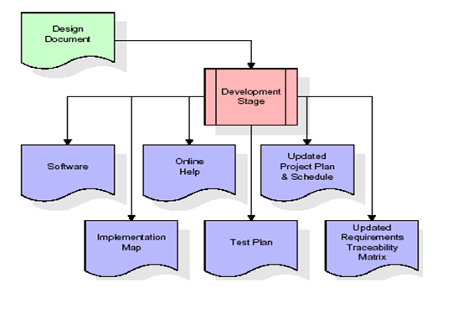
The RTM will be updated to show that each developed artifact is linked to a specific design element, and that each developed artifact has one or more corresponding test case items. At this point, the RTM is in its final configuration. The outputs of the development stage include a fully functional set of software that satisfies the requirements and design elements previously documented, an online help system that describes the operation of the software, an implementation map that identifies the primary code entry points for all major system functions, a test plan that describes the test cases to be used to validate the correctness and completeness of the software, an updated RTM, and an updated project plan.
Integration & Test Stage:
During the integration and test stage, the software artifacts, online help, and test data are migrated from the development environment to a separate test environment. At this point, all test cases are run to verify the correctness and completeness of the software. Successful execution of the test suite confirms a robust and complete migration capability. During this stage, reference data is finalized for production use and production users are identified and linked to their appropriate roles. The final reference data (or links to reference data source files) and production user list are compiled into the Production Initiation Plan.

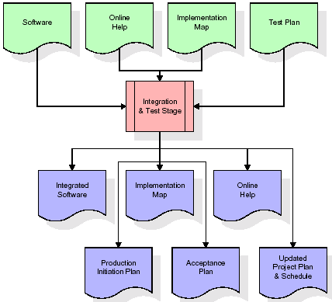
The outputs of the integration and test stage include an integrated set of software, an online help system, an implementation map, a production initiation plan that describes reference data and production users, an acceptance plan which contains the final suite of test cases, and an updated project plan.
- Installation & Acceptance Test:
During the installation and acceptance stage, the software artifacts, online help, and initial production data are loaded onto the production server. At this point, all test cases are run to verify the correctness and completeness of the software. Successful execution of the test suite is a prerequisite to acceptance of the software by the customer.
After customer personnel have verified that the initial production data load is correct and the test suite has been executed with satisfactory results, the customer formally accepts the delivery of the software.

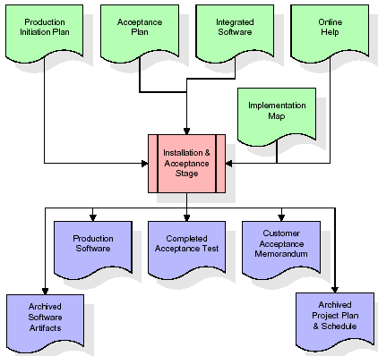

The primary outputs of the installation and acceptance stage include a production application, a completed acceptance test suite, and a memorandum of customer acceptance of the software. Finally, the PDR enters the last of the actual labor data into the project schedule and locks the project as a permanent project record. At this point the PDR "locks" the project by archiving all software items, the implementation map, the source code, and the documentation for future reference.
Maintenance:
Outer rectangle represents maintenance of a project, Maintenance team will start with requirement study, understanding of documentation later employees will be assigned work and they will undergo training on that particular assigned category. For this life cycle there is no end, it will be continued so on like an umbrella (no ending point to umbrella sticks).
3.4. Software Requirement Specification
3.4.1. Overall Description
A Software Requirements Specification (SRS) – a requirements specification for a software system is a complete description of the behavior of a system to be developed. It includes a set of use cases that describe all the interactions the users will have with the software. In addition to use cases, the SRS also contains non-functional requirements. Nonfunctional requirements are requirements which impose constraints on the design or implementation (such as performance engineering requirements, quality standards, or design constraints).
System requirements specification: A structured collection of information that embodies the requirements of a system. A business analyst, sometimes titled system analyst, is responsible for analyzing the business needs of their clients and stakeholders to help identify business problems and propose solutions. Within the systems development lifecycle domain, the BA typically performs a liaison function between the business side of an enterprise and the information technology department or external service providers. Projects are subject to three sorts of requirements:
- Business requirements describe in business terms what must be delivered or accomplished to provide value.
- Product requirements describe properties of a system or product (which could be one of several ways to accomplish a set of business requirements.)
- Process requirements describe activities performed by the developing organization. For instance, process requirements could specify .Preliminary investigation examine project feasibility, the likelihood the system will be useful to the organization. The main objective of the feasibility study is to test the Technical, Operational and Economical feasibility for adding new modules and debugging old running system. All system is feasible if they are unlimited resources and infinite time. There are aspects in the feasibility study portion of the preliminary investigation:

- ECONOMIC FEASIBILITY
A system can be developed technically and that will be used if installed must still be a good investment for the organization. In the economical feasibility, the development cost in creating the system is evaluated against the ultimate benefit derived from the new systems. Financial benefits must equal or exceed the costs. The system is economically feasible. It does not require any addition hardware or software. Since the interface for this system is developed using the existing resources and technologies available at NIC, There is nominal expenditure and economical feasibility for certain.
- Operational Feasibility
Proposed projects are beneficial only if they can be turned out into information system. That will meet the organization’s operating requirements. Operational feasibility aspects of the project are to be taken as an important part of the project implementation. This system is targeted to be in accordance with the above-mentioned issues. Beforehand, the management issues and user requirements have been taken into consideration. So there is no question of resistance from the users that can undermine the possible application benefits. The well-planned design would
Ensure the optimal utilization of the computer resources and would help in the improvement of performance status.
- TECHNICAL FEASIBILITY
Earlier no system existed to cater to the needs of ‘Secure Infrastructure Implementation System’. The current system developed is technically feasible. It is a web based user interface for audit workflow at NIC-CSD. Thus it provides an easy access to .the users. The database’s purpose is to create, establish and maintain a workflow among various entities in order to facilitate all concerned users in their various capacities or roles. Permission to the users would be granted based on the roles specified. Therefore, it provides the technical guarantee of accuracy, reliability and security.
3.4.2. External Interface Requirements
User Interface
The user interface of this system is a user-friendly python Graphical User Interface.
Hardware Interfaces
The interaction between the user and the console is achieved through python capabilities.
Software Interfaces
The required software is python.
SYSTEM REQUIREMENT:
HARDWARE REQUIREMENTS:

Processor - Intel i3(min)
- Speed - 1.1 GHz
- RAM - 4GB (min)
- Hard Disk - 500 GB
SOFTWARE REQUIREMENTS:
- Operating System - Windows10(min)
- Programming Language - Python (3.7.0) With Jupyter Notebook

4. SYSTEM DESIGN
UML Diagram:
Class Diagram:
The class diagram is the main building block of object oriented modeling. It is used both for general conceptual modeling of the systematic of the application, and for detailed modeling translating the models into programming code. Class diagrams can also be used for data modeling. The classes in a class diagram represent both the main objects, interactions in the application and the classes to be programmed. In the diagram, classes are represented with boxes which contain three parts:
- The upper part holds the name of the class
- The middle part contains the attributes of the class
- The bottom part gives the methods or operations the class can take or undertake.

Use case Diagram:
A use case diagram at its simplest is a representation of a user's interaction with the system and depicting the specifications of a use case. A use case diagram can portray the different types of users of a system and the various ways that they interact with the system. This type of diagram is typically used in conjunction with the textual use case and will often be accompanied by other types of diagrams as well.

Sequence Diagram:
A sequence diagram is a kind of interaction diagram that shows how processes operate with one another and in what order. It is a construct of a Message Sequence Chart. A sequence diagram shows object interactions arranged in time sequence. It depicts the objects and classes involved in the scenario and the sequence of messages exchanged between the objects needed to carry out the functionality of the scenario. Sequence diagrams are typically associated with use case realizations in the Logical View of the system under development. Sequence diagrams are sometimes called event diagrams, event scenarios, and timing diagrams.

Collaboration diagram:
A collaboration diagram describes interactions among objects in terms of sequenced messages. Collaboration diagrams represent a combination of information taken from class, sequence, and use case diagrams describing both the static structure and dynamic behavior of a system.

Component Diagram:
In the Unified Modeling Language, a component diagram depicts how components are wired together to form larger components and or software systems. They are used to illustrate the structure of arbitrarily complex systems.
Components are wired together by using an assembly connector to connect the required interface of one component with the provided interface of another component. This illustrates the service consumer - service provider relationship between the two components.
Deployment Diagram:
A deployment diagram in the Unified Modeling Language models the physical deployment of artifacts on nodes. To describe a web site, for example, a deployment diagram would show what hardware components ("nodes") exist (e.g., a web server, an application server, and a database server), what software components ("artifacts") run on each node (e.g., web application, database), and how the different pieces are connected (e.g. JDBC, REST, RMI).
The nodes appear as boxes, and the artifacts allocated to each node appear as rectangles within the boxes. Nodes may have sub nodes, which appear as nested boxes. A single node in a deployment diagram may conceptually represent multiple physical nodes, such as a cluster of database servers.

Activity Diagram:
Activity diagram is another important diagram in UML to describe dynamic aspects of the system. It is basically a flow chart to represent the flow form one activity to another activity. The activity can be described as an operation of the system. So the control flow is drawn from one operation to another. This flow can be sequential, branched or concurrent.

Calculate Metrics

Train Logistic Regression

Train SVM

Train KNN

Train XG BOOST

Comparison Graph

Predict

Data Flow Diagram:
Data flow diagrams illustrate how data is processed by a system in terms of inputs and outputs. Data flow diagrams can be used to provide a clear representation of any business function. The technique starts with an overall picture of the business and continues by analyzing each of the functional areas of interest. This analysis can be carried out in precisely the level of detail required. The technique exploits a method called top-down expansion to conduct the analysis in a targeted way.
As the name suggests, Data Flow Diagram (DFD) is an illustration that explicates the passage of information in a process. A DFD can be easily drawn using simple symbols. Additionally, complicated processes can be easily automated by creating DFDs using easy-to-use, free downloadable diagramming tools. A DFD is a model for constructing and analyzing information processes. DFD illustrates the flow of information in a process depending upon the inputs and outputs. A DFD can also be referred to as a Process Model. A DFD demonstrates business or technical process with the support of the outside data saved, plus the data flowing from the process to another and the end results.

User

1. Calculate Metrics 2. Successfully Calculate Metrics
3. Train Logistic Regression 4. Successfully Train Logistic Regression
5. Train SVM 6. Successfully Train SVM
7. Train KNN 8. Successfully Train KNN
9. Train XG BOOST 10. Successfully Train XG BOOST
11. Comparison Graph 12. Successfully Comparison Graph
13. Predict 14. Successfully Predict

System

5. IMPLEMETATION
5.1 PYTHON
* One of the most popular languages is Python. Guido van Rossum released this language in 1991. Python is available on the Mac, Windows, and Raspberry Pi operating systems. The syntax of Python is simple and identical to that of English. When compared to Python, it was seen that the other language requires a few extra lines.
*It is an interpreter-based language because code may be run line by line after it has been written. This implies that rapid prototyping is possible across all platforms. Python is a big language with a free, binary-distributed interpreter standard library.
* It is inferior to maintenance that is conducted and is straightforward to learn. It is an object-oriented, interpreted programming language. It supports several different programming paradigms in addition to object-oriented programming, including functional and procedural programming.
* It supports several different programming paradigms in addition to object-oriented programming, including practical and procedural programming. Python is mighty while maintaining a relatively straightforward syntax. Classes, highly dynamic data types, modules, and exceptions are covered. Python can also be utilised by programmes that require programmable interfaces as an external language.
Here are some key features and characteristics of Python:
- Readability: Python emphasizes code readability with its clean and intuitive syntax. It uses indentation and whitespace to structure code blocks, making it easy to understand and maintain.
- Easy to Learn: Python's simplicity and readability make it an excellent choice for beginners. Its straightforward syntax and extensive documentation make it accessible for newcomers to programming.
- Interpreted Language: Python is an interpreted language, meaning that it doesn't need to be compiled before running. The Python interpreter reads and executes the code directly, making the development process faster and more interactive.
- Cross-platform Compatibility: Python is available for major operating systems like Windows, macOS, and Linux. This cross-platform compatibility allows developers to write code once and run it on different platforms without modifications.
- Large Standard Library: Python comes with a vast standard library that provides ready-to-use modules and functions for various tasks. It covers areas such as file I/O, networking, regular expressions, databases, and more, saving developers time and effort.
- Extensible and Modular: Python supports modular programming, enabling developers to organize code into reusable modules and packages. Additionally, Python allows integrating modules written in other languages, such as C or C++, providing flexibility and performance optimizations.
- Wide Range of Libraries and Frameworks: Python has a vibrant ecosystem with numerous third-party libraries and frameworks. These libraries, such as NumPy, pandas, TensorFlow, and Django, extend Python's capabilities for specific domains, making it a powerful tool for diverse applications.
- Object-Oriented: Python supports object-oriented programming (OOP) principles, allowing developers to create and work with classes and objects. OOP provides a structured approach to code organization, promoting code reuse and modularity.
- Dynamic Typing: Python is dynamically typed, meaning variable types are determined at runtime. Developers do not need to declare variable types explicitly, which enhances flexibility and simplifies code writing.
5.2 Installation
To install Python on your computer, follow these basic steps:
- Step 1: Visit the Python website Go to the official Python website at https://www.python.org/.
- Step 2: Select the operating system Choose the appropriate installer for your operating system. Python supports Windows, macOS, and various Linux distributions. Make sure to select the correct version that matches your operating system.
- Step 3: Check which version of Python is installed; if the 3.7.0 version is not there, uninstall it through the control panel and
- Step 4: Install Python 3.7.0 using Cmd.
- Step 5: Install the all libraries that required to run the project
- Step 6: Run
5.3 Python Features:
- Easy: Because Python is a more accessible and straightforward language, Python programming is easier to learn.
- Interpreted language: Python is an interpreted language, therefore it can be used to examine the code line by line and provide results.
- Open Source: Python is a free online programming language since it is open-source.
- Portable: Python is portable because the same code may be used on several computer standard
- libraries: Python offers a sizable library that we may utilize to create applications quickly.
- GUI: It stands for GUI (Graphical User Interface)
- Dynamical typed: Python is a dynamically typed language, therefore the type of the value will be determined at runtime.
5.4 Python GUI (Tkinter)
- Python provides a wide range of options for GUI development (Graphical User Interfaces).
- Tkinter, the most widely used GUI technique, is used for all of them.
- The Tk GUI toolkit offered by Python is used with the conventional Python interface.
- Tkinter is the easiest and quickest way to write Python GUI programs.
- Using Tkinter, creating a GUI is simple.
- A part of Python's built-in library is Tkinter. The GUI programs were created.
- Python and Tkinter together give a straightforward and quick way. The Tk GUI toolkit's object-oriented user interface is called Tkinter.

Making a GUI application is easy using Tkinter. Following are the steps:
1) Install the Tkinter module in place.
2) The GUI applicatioMakeske the primary window
3) Include one or more of the widgets mentioned above in the GUI application.
4) Set up the main event loop such that it reacts to each user-initiated event.
Although Tkinter is the only GUI framework included in the Python standard library, Python includes a GUI framework. The default library for Python is called Tkinter. Tk is a scripting language often used in designing, testing, and developing GUIs. Tk is a free, open-source widget toolkit that may be used to build GUI applications in a wide range of computer languages.
5.5 Python IDLE
- Python IDLE offers a full-fledged file editor, which gives you the ability to write and execute Python programs from within this program. The built-in file editor also includes several features, like code completion and automatic indentation, that will speed up your coding workflow.
- Guido Van Rossum named Python after the British comedy group Monty Python while the name IDLE was chosen to pay tribute to Eric Idle, who was one of the Monty Python's founding members. IDLE comes bundled with the default implementation of the Python language since the 01.5. 2b1 release
- IDLE is used to execute statements similar to Python Shell. IDLE is used to create, modify, and execute Python code. IDLE provides a fully-featured text editor to write Python scripts and provides features like syntax highlighting, auto-completion, and smart indent.
- IDLE has two modes: interactive and script. We wrote our first program, “Hello, World!” in interactive mode. Interactive mode immediately returns the results of commands you enter into the shell. In script mode, you will write a script and then run it.
- The IDE Python IDLE is a good place to start as it helps you become familiar with the way Python works and understand its syntax. This IDE is good to start programming in Python due to its great debugger, but once you are fluent and start developing projects it is necessary to jump to another, more complete IDE.
- Python IDLE (Integrated Development and Learning Environment) is an interactive development environment included with the Python programming language. It provides a convenient way to write, execute, and debug Python code.
When you install Python, IDLE is typically installed along with it. To open IDLE, you can follow these steps:
- Open the command prompt (Windows) or terminal (macOS/Linux).
- Type "idle" and press Enter. Alternatively, you can specify the version with "idle3" or "idle2" for Python 3 or Python 2, respectively.
- Once IDLE is launched, you will see the Python shell, which is an interactive environment where you can type and execute Python code directly.
Here are some features and functionalities provided by Python IDLE:
- Editor: IDLE includes a text editor where you can write your Python code. It offers syntax highlighting, automatic indentation, and code completion to enhance your coding experience.
- Interactive Shell: The Python shell in IDLE allows you to execute Python code interactively. You can type commands, statements, or function calls directly in the shell, and Python will execute them immediately.
- Debugging: IDLE provides basic debugging capabilities to help you find and fix errors in your code. You can set breakpoints, step through code, inspect variables, and track the program's execution.
- Python Help: IDLE provides access to the Python documentation and built-in help. You can access the help menu to find information about Python modules, functions, classes, and more.
- Script Execution: In addition to the interactive shell, IDLE allows you to run Python scripts stored in files. You can write your code in the editor and execute it as a script to see the output or interact with the program.
- Customization: IDLE can be customized to suit your preferences. You can modify settings related to syntax highlighting, indentation, fonts, and more.
- Python IDLE serves as a beginner-friendly development environment and learning tool. It is suitable for writing small scripts, testing code snippets, experimenting with Python features, and learning the language's basics. However, for more advanced development projects, you may consider using other code editors or integrated development environments (IDEs) that provide additional features and better project management capabilities.
5.6 Libraries
In Python, libraries (also referred to as modules or packages) are collections of pre-written code that provide additional functionality and tools to extend the capabilities of the Python language. Libraries contain reusable code that developers can leverage to perform specific tasks without having to write everything from scratch.
Python libraries are designed to solve common problems, such as handling data, performing mathematical operations, interacting with databases, working with files, implementing networking protocols, creating graphical user interfaces (GUIs), and much more. They provide ready-to-use functions, classes, and methods that simplify complex operations and save development time.
Libraries in Python offer various advantages:
- Code Reusability:
- Efficiency:
- Collaboration
- Domain-Specific Functionality
- To use a Python library, you need to install it first.
There are some libraries following:
- Pandas:
Pandas are a Python computer language library for data analysis and manipulation. It offers a specific operation and data format for handling time series and numerical tables. It differs significantly from the release3-clause of the BSD license. It is a well-liked open-source of opinion that is utilized in machine learning and data analysis.
Pandas are a Python package providing fast, flexible, and expressive data structures designed to make working with “relational” or “labeled” data both easy and intuitive. It aims to be the fundamental high-level building block for doing practical, real-world data analysis in Python. Pandas are a Python library used for working with data sets.
- It has functions for analysing, cleaning, exploring, and manipulating data.
- The name "Pandas" has a reference to both "Panel Data", and "Python Data Analysis" and was created by Wes McKinney in 2008.
- Pandas allow us to analyse big data and make conclusions based on statistical theories.
- Pandas can clean messy data sets, and make them readable and relevant.
Relevant data is very important in data science. Pandas are a Python library for data analysis. Started by Wes McKinney in 2008 out of a need for a powerful and flexible quantitative analysis tool, pandas have grown into one of the most popular Python libraries. It has an extremely active community of contributors. The name is derived from the term "panel data", an econometrics term for data sets that include observations over multiple time periods for the same individuals. Its name is a play on the phrase "Python data analysis" itself.
- NumPy:
The NumPy Python library for multi-dimensional, big-scale matrices adds a huge number of high-level mathematical functions. It is possible to modify NumPy by utilizing a Python library. Along with line, algebra, and the Fourier transform operations, it also contains several matrices-related functions.
NumPy can be used to perform a wide variety of mathematical operations on arrays. It adds powerful data structures to Python that guarantee efficient calculations with arrays and matrices and it supplies an enormous library of high-level mathematical functions that operate on these arrays and matrices.
- NumPy is a Python library used for working with arrays.
- It also has functions for working in domain of linear algebra, Fourier transform, and matrices.
- NumPy was created in 2005 by Travis Oliphant. It is an open source project and you can use it freely.
- NumPy stands for Numerical Python.
- In Python we have lists that serve the purpose of arrays, but they are slow to process.
- NumPy aims to provide an array object that is up to 50x faster than traditional Python lists.
- The array object in NumPy is called ndarray, it provides a lot of supporting functions that make working with ndarray very easy.
- Arrays are very frequently used in data science, where speed and resources are very important.

- Matplotlib:
It is a multi-platform, array-based data visualization framework built to interact with the whole SciPy stack. MATLAB is proposed as an open-source alternative. Matplotlib is a Python extension and a cross-platform toolkit for graphical plotting and visualization.
Matplotlib is a popular Python library for creating static, animated, and interactive visualizations. It provides a flexible and comprehensive set of tools for generating plots, charts, histograms, scatter plots, and more. Matplotlib is widely used in various fields, including data analysis, scientific research, and data visualization.
Here are some key features and functionalities of the Matplotlib library:
- Plotting Functions
- Customization Options
- Multiple Interfaces
- Integration with NumPy and pandas
- Subplots and Figures:
- Saving and Exporting

- Scikit-learn:
The most stable and practical machine learning library for Python is scikit-learn. Regression, dimensionality reduction, classification, and clustering are just a few of the helpful tools it provides through the Python interface for statistical modeling and machine learning. It is an essential part of the Python machine learning toolbox used by JP Morgan. It is frequently used in various machine learning applications, including classification and predictive analysis.
Scikit-learn (also referred to as sklearn) is a widely used open-source machine learning library for Python. It provides a comprehensive set of tools and algorithms for various machine learning tasks, including classification, regression, clustering, dimensionality reduction, model selection, and pre-processing.
Here are some key features and functionalities of the Scikit-learn library:
- Easy-to-Use Interface:
- Broad Range of Algorithms:
- Data Pre-processing and Feature Engineering:
- Model Evaluation and Validation:
- Integration with NumPy and pandas:
- Robust Documentation and Community Support:

- Keras:
* Google's Keras is a cutting-edge deep learning API for creating neural networks. It is created in Python and is designed to simplify the development of neural networks. Additionally, it enables the use of various neural networks for computation. Deep learning models are developed and tested using the free and open-source Python software known as Keras.
Keras is a high-level deep learning library for Python. It is designed to provide a user-friendly and intuitive interface for building and training deep learning models. Keras acts as a front-end API, allowing developers to define and configure neural networks while leveraging the computational backend engines, such as Tensor Flow or Theano.
Here are some key features and functionalities of the Keras library:
- User-Friendly API
- Multi-backend Support
- Wide Range of Neural Network Architectures
- Pre-trained Models and Transfer Learning:
- Easy Model Training and Evaluation:
- GPU Support:

- h5py:
* The h5py Python module offers an interface for the binary HDF5 data format. Thanks to p5py, the top can quickly halt the vast amount of numerical data and alter it using the NumPy library. It employs common syntax for Python, NumPy, and dictionary arrays.
h5py is a Python library that provides a simple and efficient interface for working with datasets and files in the Hierarchical Data Format 5 (HDF5) format. HDF5 is a versatile data format commonly used for storing and managing large volumes of numerical data.
Here are some key features and functionalities of the h5py library:
  - HDF5 File Access
  - Dataset Handling:
  - Group Organization:
  - Attributes:
  - Compatibility with NumPy
  - Performance

- Tensor flow
TensorFlow is a Python library for fast numerical computing created and released by Google. It is a foundation library that can be used to create Deep Learning models directly or by using wrapper libraries that simplify the process built on top of TensorFlow. TensorFlow is an end-to-end open source platform for machine learning. TensorFlow is a rich system for managing all aspects of a machine learning system; however, this class focuses on using a particular TensorFlow API to develop and train machine learning models.
TensorFlow is a popular open-source library for machine learning and deep learning. It provides a comprehensive set of tools, APIs, and computational resources for building and training various types of machine learning models, especially neural networks.
Here are some key features and functionalities of TensorFlow:
- Neural Network Framework:
- Computational Graphs
- Automatic Differentiation
- GPU and TPU Support
- Distributed Computing
- Deployment Capabilities

- Tkinter
Tkinter is an acronym for "Tk interface". Tk was developed as a GUI extension for the Tcl scripting language by John Ousterhout. The first release was in 1991. Tkinter is the de facto way in Python to create Graphical User interfaces (GUIs) and is included in all standard Python Distributions. In fact, it's the only framework built into the Python standard library.
Tkinter is a standard Python library used for creating graphical user interfaces (GUIs). It provides a set of modules and classes that allow you to develop interactive and visually appealing desktop applications.
Here are some key features and functionalities of Tkinter:
- Cross-Platform Compatibility
- Simple and Easy-to-Use
- Widgets and Layout Management
- Event-Driven Programming
- Customization and Styling
- Integration with Other Libraries

- NLTK
NLTK is a toolkit build for working with NLP in Python. It provides us various text processing libraries with a lot of test datasets. A variety of tasks can be performed using NLTK such as tokenizing, parse tree visualization, etc NLTK (Natural Language Toolkit) is the go-to API for NLP (Natural Language Processing) with Python. It is a really powerful tool to pre-process text data for further analysis like with ML models for instance. It helps convert text into numbers, which the model can then easily work with.
NLTK (Natural Language Toolkit) is a Python library widely used for working with human language data and implementing natural language processing (NLP) tasks. It provides a set of tools, corpora, and resources for tasks such as tokenization, stemming, tagging, parsing, sentiment analysis, and more.
Here are some key features and functionalities of NLTK:
- Text Processing
- Part-of-Speech Tagging
- Named Entity Recognition
- Chunking and Parsing
- Sentiment Analysis:
- WordNet Integration:

- Scipy
SciPy is a collection of mathematical algorithms and convenience functions built on the NumPy extension of Python. It adds significant power to the interactive Python session by providing the user with high-level commands and classes for manipulating and visualizing data.
SciPy is a powerful scientific computing library for Python that provides a wide range of mathematical algorithms and functions. It builds upon NumPy, another fundamental library for numerical computing, and extends its capabilities by adding additional tools for scientific and technical computing tasks.
Here are some key features and functionalities of SciPy:
- Numerical Integration:
- Optimization and Root Finding
- Linear Algebra
- Signal and Image Processing
- Statistics
5.2 Sample Code:
#importing python classes and packages
import matplotlib.pyplot as plt
from tkinter.filedialog import askopenfilename
import numpy as np
import pandas as pd
from sklearn.preprocessing import LabelEncoder
from sklearn.metrics import accuracy_score
from sklearn.preprocessing import MinMaxScaler
from sklearn.naive_bayes import GaussianNB
import seaborn as sns
from sklearn.metrics import precision_score
from sklearn.metrics import recall_score
from sklearn.metrics import f1_score
from sklearn.model_selection import train_test_split
from xgboost import XGBClassifier
from sklearn.ensemble import RandomForestClassifier
from sklearn.neighbors import KNeighborsClassifier
from sklearn.metrics import confusion_matrix
from sklearn import svm
from sklearn.linear_model import LogisticRegression
import shap
from imblearn.over_sampling import SMOTE
from sklearn.feature_selection import chi2
from sklearn.feature_selection import SelectKBest
import catboost as cb
#load and display dataset values
dataset = pd.read_csv("Dataset/healthcare-dataset-stroke-data.csv")
dataset.fillna(0, inplace = True)
dataset
#finidng and plotting labels in dataset and in below graph we can see dataset is highly imbalance as one class contains
#so many instances and other contains very few instances and this imbalance we will handle using SMOTE
unique, count = np.unique(dataset['stroke'], return_counts = True)
labels = ['Normal', 'Stroke']
height = count
bars = labels
y_pos = np.arange(len(bars))
plt.bar(y_pos, height)
plt.xticks(y_pos, bars)
plt.xlabel("Target (0) Normal (1) Stroke")
plt.ylabel("Count")
plt.title("Target Samples Distribution from Original Dataset")
plt.show()
#graphs of different labels found in dataset
plt.pie(count, labels = labels)
plt.title("Distribution of Target Graph")
plt.show()
#find and plot features cluster correlation graph
plt.figure(figsize=(14,8))
sns.heatmap(dataset.corr(), cmap='coolwarm', annot=True)
plt.title("Features Clustering Graph")
plt.show()
#plot graph of stroke patient based on age and gender
temp = dataset.loc[dataset['stroke'] == 1]
sns.violinplot(x='gender',y='age',data=temp,palette='rainbow')
plt.title("Stroke Patient Age on Gender")
plt.show()
#plot graph of stroke patient based on age and gender in bar graph
data = temp[['age', 'gender']]
data.groupby(['age', 'gender']).size().unstack().plot(kind='bar', stacked=True, figsize=(14,6))
plt.xlabel("Age")
plt.ylabel(count)
plt.title("Age Distribution of Stroke Patients")
#graph of Stroke Patient using BMI on Gender
sns.violinplot(x='gender',y='bmi',data=temp,palette='rainbow')
plt.title("Stroke Patient BMI on Gender")
plt.xlabel("Gender")
plt.ylabel("BMI")
plt.show()
#finding and plotting graph in stroke patient suffering from hyper tension
data = temp[['hypertension']]
data.groupby(['hypertension']).size().plot(kind='barh', color=['g', 'r'])
plt.xlabel("Total")
plt.ylabel("Hypertension 1 (yes) & 0 (No)")
plt.title("Stroke Patient's Hypertension Status")
#finding and plotting graph in stroke patient suffering from heart disease
data = temp[['heart_disease']]
data.groupby(['heart_disease']).size().plot(kind='barh', color=['g', 'r'])
plt.xlabel("Total")
plt.ylabel("Heart Disease 1 (yes) & 0 (No)")
plt.title("Stroke Patient's Heart Disease")
#finding and plotting graph in stroke patient with average glucose level
sns.violinplot(x='gender',y='avg_glucose_level',data=temp,palette='rainbow')
plt.title("Stroke Patient's Average Glucose Level on Gender.")
plt.xlabel("Gender")
plt.ylabel("Average Glucose Level")
plt.show()
#finding and plotting graph in stroke patient doing smoking
data = temp[['smoking_status']]
data.groupby(['smoking_status']).size().plot(kind='barh', color=['b', 'r', 'g', 'y'])
plt.xlabel("Total")
plt.ylabel("Smoking Status")
plt.title("Stroke Patient's Smoking Status")
#finding and plotting graph of stroke patient using residence type
unique, count = np.unique(temp['Residence_type'], return_counts=True)
plt.pie(count, labels = unique, autopct='%1.2f%%')
plt.title("Stroke Patients Residence Type Graph")
plt.show()
#convert categorical (non-numeric data) into numeric format using label encoder class
encoder1 = LabelEncoder()
encoder2 = LabelEncoder()
encoder3 = LabelEncoder()
encoder4 = LabelEncoder()
encoder5 = LabelEncoder()
dataset['gender'] = pd.Series(encoder1.fit_transform(dataset['gender'].astype(str)))#encode all str columns to numeric
dataset['ever_married'] = pd.Series(encoder2.fit_transform(dataset['ever_married'].astype(str)))#encode all str columns to numeric
dataset['work_type'] = pd.Series(encoder3.fit_transform(dataset['work_type'].astype(str)))
dataset['Residence_type'] = pd.Series(encoder4.fit_transform(dataset['Residence_type'].astype(str)))
dataset['smoking_status'] = pd.Series(encoder5.fit_transform(dataset['smoking_status'].astype(str)))
dataset
#drop ID column and then extract X training features and Y target label
Y = dataset['stroke'].ravel()
dataset.drop(['id', 'stroke'], axis = 1,inplace=True)
X = dataset.values
#normalized dataset features
sc1 = MinMaxScaler(feature_range = (0, 1))
X = sc1.fit_transform(X)#features normalization
print("Normalize Features : "+str(X))
#now apply Smote to balance dataset
sm = SMOTE()
X, Y = sm.fit_resample(X, Y)
unique, count = np.unique(Y, return_counts=True)
height = count
bars = labels
y_pos = np.arange(len(bars))
plt.bar(y_pos, height)
plt.xticks(y_pos, bars)
plt.xlabel("Target (0) Normal (1) Stroke")
plt.ylabel("Count")
plt.title("Target Samples Distribution after applying SMOTE")
plt.show()
#now select features uisng CHI Square features selection algorithm
print("Features available in dataset before selection : "+str(X.shape[1]))
features_selector = SelectKBest(score_func=chi2, k = 9)
selected_features = features_selector.fit_transform(X, Y)
print("Features available in dataset after selection : "+str(selected_features.shape[1]))
#split dataset into train and test
X_train, X_test, y_train, y_test = train_test_split(selected_features, Y, test_size=0.2) #split dataset into train and test
print()
print("Dataset train & test split as 80% dataset for training and 20% for testing")
print("Training Size (80%): "+str(X_train.shape[0])) #print training and test size
print("Testing Size (20%): "+str(X_test.shape[0]))
print()
#define global variables to calculate and store accuracy and other metrics
precision = []
recall = []
fscore = []
accuracy = []
#function to calculate various metrics such as accuracy, precision etc
def calculateMetrics(algorithm, predict, testY):
p = precision_score(testY, predict,average='macro') * 100
r = recall_score(testY, predict,average='macro') * 100
f = f1_score(testY, predict,average='macro') * 100
a = accuracy_score(testY,predict)*100
print()
print(algorithm+' Accuracy : '+str(a))
print(algorithm+' Precision : '+str(p))
print(algorithm+' Recall : '+str(r))
print(algorithm+' FMeasure : '+str(f))
accuracy.append(a)
precision.append(p)
recall.append(r)
fscore.append(f)
labels = unique
conf_matrix = confusion_matrix(testY, predict)
plt.figure(figsize =(5, 5))
ax = sns.heatmap(conf_matrix, xticklabels = labels, yticklabels = labels, annot = True, cmap="viridis" ,fmt ="g");
ax.set_ylim([0,len(labels)])
plt.title(algorithm+" Confusion matrix")
plt.ylabel('True class')
plt.xlabel('Predicted class')
plt.show()
#train random forest algorithm on training dataset and test its prediction capability on test data
#now train Random Forest algorithm
rf_cls = RandomForestClassifier()
rf_cls.fit(X_train, y_train)
predict = rf_cls.predict(X_test)
calculateMetrics("Random Forest", predict, y_test)
#now train LogisticRegression algorithm
lr_cls = LogisticRegression()#define regression object
lr_cls.fit(X_train, y_train)#train regression on training data
predict = lr_cls.predict(X_test)#perform prediction on test data
calculateMetrics("Logistic Regression", predict, y_test)#calculate accuracy and other metrics
#now train SVM algorithm
svm_cls = svm.SVC()#define SVM object
svm_cls.fit(X_train, y_train)#train SVM on training data
predict = svm_cls.predict(X_test)#perform prediction on test data
calculateMetrics("SVM", predict, y_test)#calculate accuracy and other metrics
#now train KNN algorithm
knn_cls = KNeighborsClassifier(n_neighbors=3)#define KNN object
knn_cls.fit(X_train, y_train)#train KNN on training data
predict = knn_cls.predict(X_test)#perform prediction on test data
calculateMetrics("KNN", predict, y_test)#calculate accuracy and other metrics
#now train Naive Bayes algorithm
nb_cls = GaussianNB()#define Naive Bayes object
nb_cls.fit(X_train, y_train)#train Naive Bayes on training data
predict = nb_cls.predict(X_test)#perform prediction on test data
calculateMetrics("Naive Bayes", predict, y_test)#calculate accuracy and other metrics
#now train XGBoost algorithm
xg_cls = XGBClassifier(n_estimators=10)#define XGBOOST object
xg_cls.fit(X_train, y_train)#train XGBOost on training data
predict = xg_cls.predict(X_test)#perform prediction on test data
calculateMetrics("XGBoost", predict, y_test)#calculate accuracy and other metrics
#now traon extension CATBOOST algorithm as extension which is more advanced then other ML algorithm
cb_cls = cb.CatBoostClassifier(iterations=300, learning_rate=0.1)
cb_cls.fit(X_train, y_train)#train CatBoost on training data
predict = cb_cls.predict(X_test)#perform prediction on test data
calculateMetrics("Extension CatBoost", predict, y_test)#calculate accuracy and other metrics
#using shapely we can explain model which can show what features help in gaining more accuracy
columns = ['gender','age','hypertension','heart_disease','ever_married','work_type','Residence_type','avg_glucose_level','bmi']
explainer = shap.TreeExplainer(cb_cls)
shap_values = explainer.shap_values(X_train) #explainer will set on training data
shap.summary_plot(shap_values, X_train, feature_names=columns)#now explain features importance using plot
#plot comparison between all algortihms
df = pd.DataFrame([['Random Forest','Precision',precision[0]],['Random Forest','Recall',recall[0]],['Random Forest','F1 Score',fscore[0]],['Random Forest','Accuracy',accuracy[0]],
['Logistic Regression','Precision',precision[1]],['Logistic Regression','Recall',recall[1]],['Logistic Regression','F1 Score',fscore[1]],['Logistic Regression','Accuracy',accuracy[1]],
['SVM','Precision',precision[2]],['SVM','Recall',recall[2]],['SVM','F1 Score',fscore[2]],['SVM','Accuracy',accuracy[2]],
['KNN','Precision',precision[3]],['KNN','Recall',recall[3]],['KNN','F1 Score',fscore[3]],['KNN','Accuracy',accuracy[3]],
['Naive Bayes','Precision',precision[4]],['Naive Bayes','Recall',recall[4]],['Naive Bayes','F1 Score',fscore[4]],['Naive Bayes','Accuracy',accuracy[4]],
['XGBoost','Precision',precision[5]],['XGBoost','Recall',recall[5]],['XGBoost','F1 Score',fscore[5]],['XGBoost','Accuracy',accuracy[5]],
['Extension CatBoost','Precision',precision[6]],['Extension CatBoost','Recall',recall[6]],['Extension CatBoost','F1 Score',fscore[6]],['Extension CatBoost','Accuracy',accuracy[6]],
],columns=['Parameters','Algorithms','Value'])
df.pivot("Parameters", "Algorithms", "Value").plot(kind='bar')
plt.title("All Algorithms Performance Graph")
plt.show()
#showing all algorithms with scenario A and B performance values
columns = ["Algorithm Name","Precison","Recall","FScore","Accuracy"]
values = []
algorithm_names = ["Random Forest","Logistic Regression", "SVM", "KNN", "Naive Bayes", "XGBOost", "Extension CatBoost"]
for i in range(len(algorithm_names)):
values.append([algorithm_names[i],precision[i],recall[i],fscore[i],accuracy[i]])

temp = pd.DataFrame(values,columns=columns)
temp
testData = pd.read_csv("Dataset/testData.csv")#reading test data
testData.fillna(0, inplace = True)
temp = testData.values
testData['gender'] = pd.Series(encoder1.transform(testData['gender'].astype(str)))#converting non-numeric data to numeric
testData['ever_married'] = pd.Series(encoder2.transform(testData['ever_married'].astype(str)))
testData['work_type'] = pd.Series(encoder3.transform(testData['work_type'].astype(str)))
testData['Residence_type'] = pd.Series(encoder4.transform(testData['Residence_type'].astype(str)))
testData['smoking_status'] = pd.Series(encoder5.transform(testData['smoking_status'].astype(str)))
testData.drop(['id'], axis=1, inplace=True)#drop id column
testData = testData.values
test = sc1.transform(testData)#normalizing values
test = features_selector.transform(test)#select relevant features using CHI2 selector
predict = cb_cls.predict(test)#performing prediction on test data using XGBOOST
for i in range(len(predict)):
print("Test Data = "+str(temp[i])+" Predicted As ====> "+labels[predict[i]]+"\n")
6. TESTING
Implementation and Testing:
Implementation is one of the most important tasks in project is the phase in which one has to be cautions because all the efforts undertaken during the project will be very interactive. Implementation is the most crucial stage in achieving successful system and giving the users confidence that the new system is workable and effective. Each program is tested individually at the time of development using the sample data and has verified that these programs link together in the way specified in the program specification. The computer system and its environment are tested to the satisfaction of the user.
Implementation
The implementation phase is less creative than system design. It is primarily concerned with user training, and file conversion. The system may be requiring extensive user training. The initial parameters of the system should be modifies as a result of a programming. A simple operating procedure is provided so that the user can understand the different functions clearly and quickly. The different reports can be obtained either on the inkjet or dot matrix printer, which is available at the disposal of the user. The proposed system is very easy to implement. In general implementation is used to mean the process of converting a new or revised system design into an operational one.

Testing
Testing is the process where the test data is prepared and is used for testing the modules individually and later the validation given for the fields. Then the system testing takes place which makes sure that all components of the system property functions as a unit. The test data should be chosen such that it passed through all possible condition. Actually testing is the state of implementation which aimed at ensuring that the system works accurately and efficiently before the actual operation commence. The following is the description of the testing strategies, which were carried out during the testing period.
System Testing
Testing has become an System integral part of any system or project especially in the field of information technology. The importance of testing is a method of justifying, if one is ready to move further, be it to be check if one is capable to with stand the rigors of a particular situation cannot be underplayed and that is why testing before development is so critical. When the software is developed before it is given to user to user the software must be tested whether it is solving the purpose for which it is developed. This testing involves various types through which one can ensure the software is reliable. The program was tested logically and pattern of execution of the program for a set of data are repeated. Thus the code was exhaustively checked for all possible correct data and the outcomes were also checked.
Module Testing
To locate errors, each module is tested individually. This enables us to detect error and correct it without affecting any other modules. Whenever the program is not satisfying the required function, it must be corrected to get the required result. Thus all the modules are individually tested from bottom up starting with the smallest and lowest modules and proceeding to the next level. Each module in the system is tested separately. For example the job classification module is tested separately. This module is tested with different job and its approximate execution time and the result of the test is compared with the results that are prepared manually. The comparison shows that the results proposed system works efficiently than the existing system. Each module in the system is tested separately. In this system the resource classification and job scheduling modules are tested separately and their corresponding results are obtained which reduces the process waiting time.
Integration Testing
After the module testing, the integration testing is applied. When linking the modules there may be chance for errors to occur, these errors are corrected by using this testing. In this system all modules are connected and tested. The testing results are very correct. Thus the mapping of jobs with resources is done correctly by the system.
Acceptance Testing
When that user fined no major problems with its accuracy the system passers through a final acceptance test. This test confirms that the system needs the original goals, objectives and requirements established during analysis without actual execution which elimination wastage of time and money acceptance tests on the shoulders of users and management, it is finally acceptable and ready for the operation.

Test  Case  ID | Test  case  Name | TestCase  Desc. | Step | Expected | Actual | Test  Case  Status | Test  Case  Priority
01 | Calculate Metrics | Verify The calculate Metrics done or not | If The calculate Metrics may not done | We cannot do the further operations | We Can do further operations | High | High
02 | Train LR | Verify the  Train LR done or not | If the  Train LR May Not be done | We cannot do the further operations | We Can do further operations | High | High
03 | Train SVM | Verify The Train SVM done or not | If The Train SVM may not done | We cannot do the further operations | We Can do further operations | High | High
04 | Train KNN | Verify The Train KNN done or not | If The Train KNN may not done | We cannot do the further operations | We Can do further operations | High | High
05 | Train XG BOOST | Verify Train XG BOOST done or not | If The Train XG BOOST may not done | We cannot do the further operations | We Can do further operations | High | High
06 | graph | Verify The graph done or not | If The graph may not done | We cannot do the further operations | We Can do further operations | High | High
07 | Predict | Verify The Predict done or not | If The Predict  may not done | We cannot do the further operations | We Can do further operations | High | High

7. SCREEN SHOTS:

To run project double click on ‘run.bat’ file to get below screen
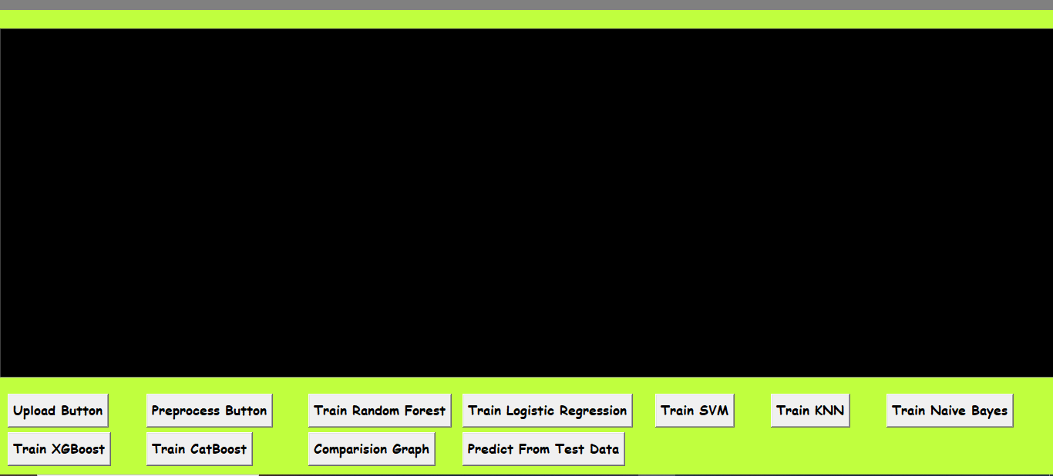
In above screen, click on upload button
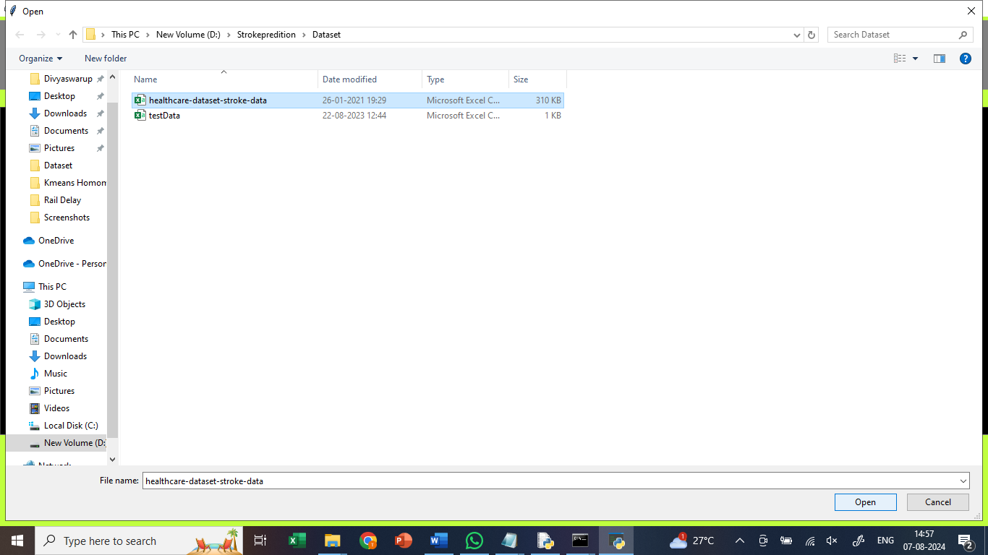
In above screen, upload healthcare dataset
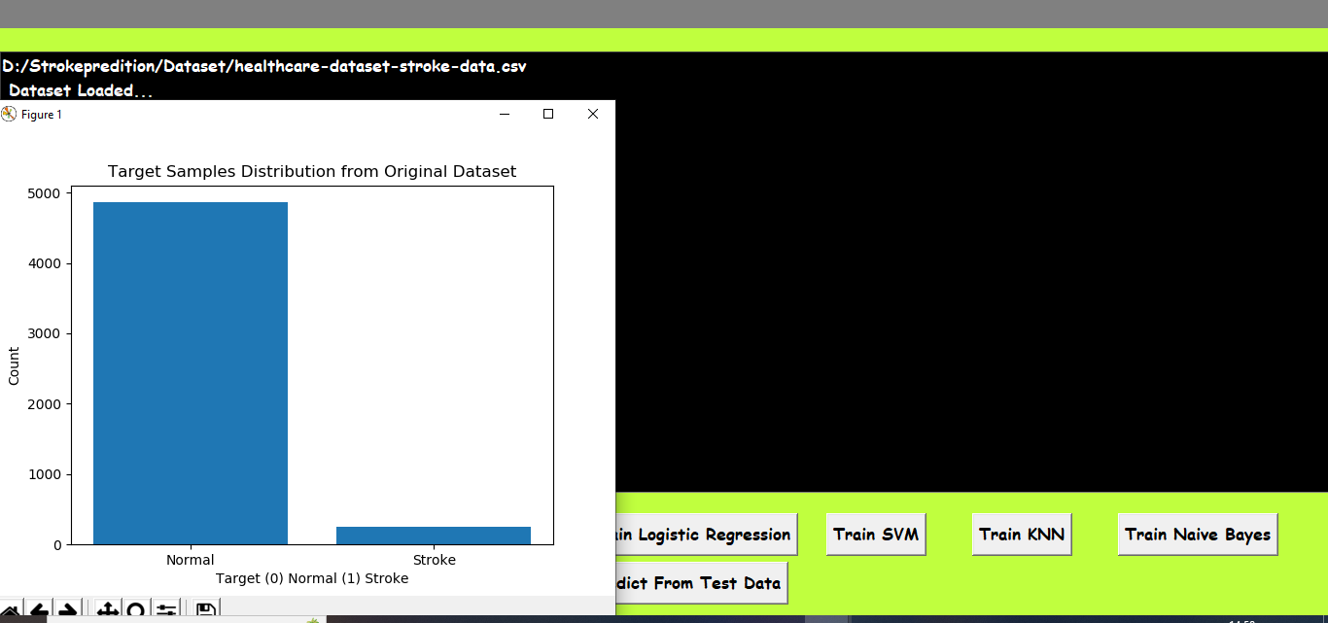
In above screen, we are getting the graph which displays the data related to normal and stroke.
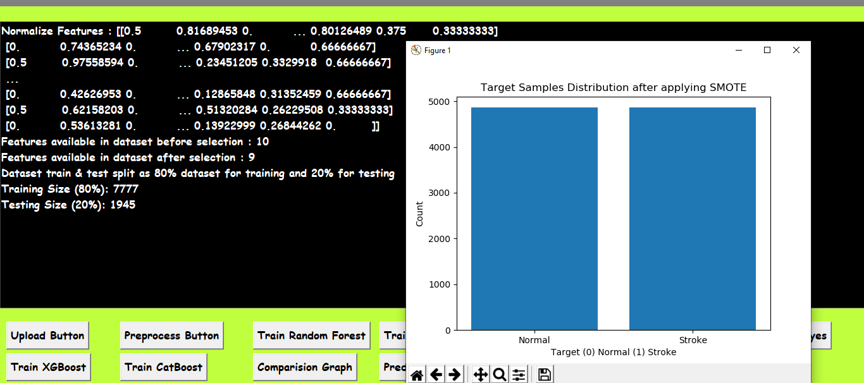
In above screen, click on preprocess button, for splitting the dataset, 80% for training and 20% for testing.
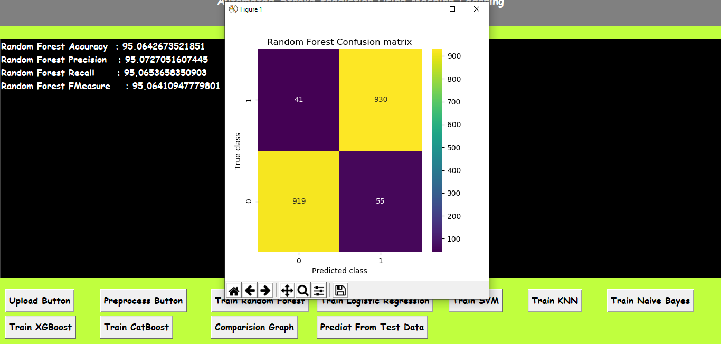
In above screen, click on Train Random Forest button, to train Random Forest and got 95% accuracy. In confusion matrix graph x-axis represents Predicted Labels and y-axis represents True Labels where blue boxes represents incorrect prediction count which are very few and yellow and light green boxes represents correct prediction count.

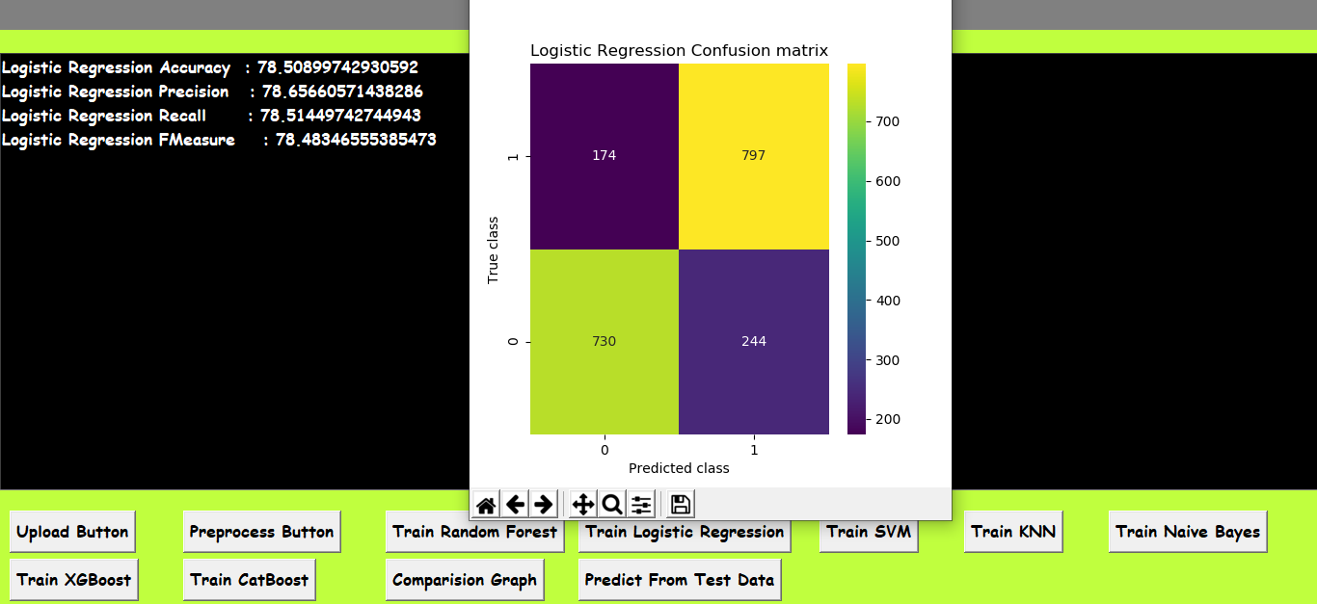
In above screen, click on Train Logistic Regression button, to train Random Forest and got 78% accuracy. In confusion matrix graph x-axis represents Predicted Labels and y-axis represents True Labels where blue boxes represents incorrect prediction count which are very few and yellow and light green boxes represents correct prediction count.

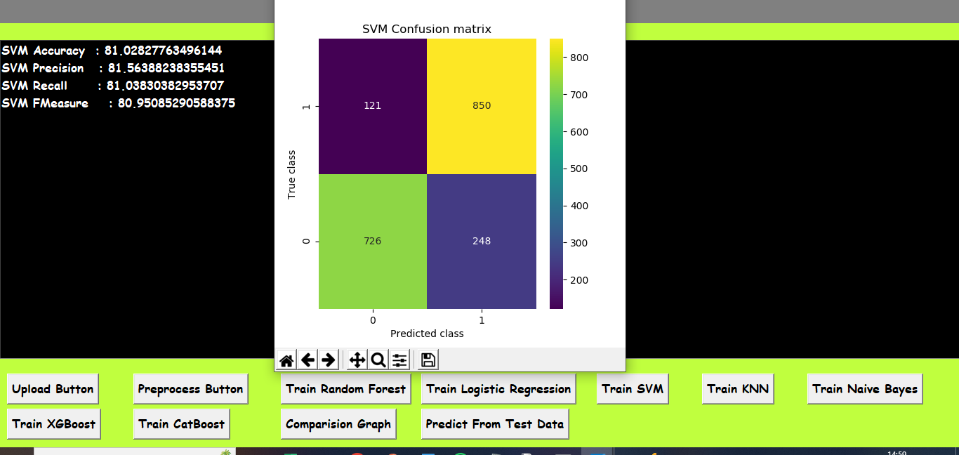
In above screen, click on Train SVM button, to train SVM and got 81% accuracy. In confusion matrix graph x-axis represents Predicted Labels and y-axis represents True Labels where blue boxes represents incorrect prediction count which are very few and yellow and light green boxes represents correct prediction count.

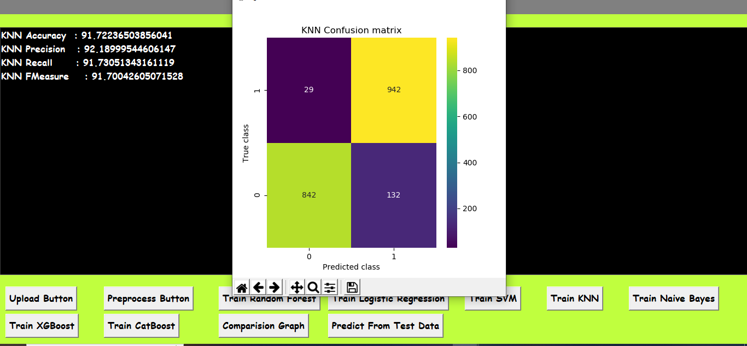
In above screen, click on Train KNN button, to train KNN and got 91% accuracy. In confusion matrix graph x-axis represents Predicted Labels and y-axis represents True Labels where blue boxes represents incorrect prediction count which are very few and yellow and light green boxes represents correct prediction count.

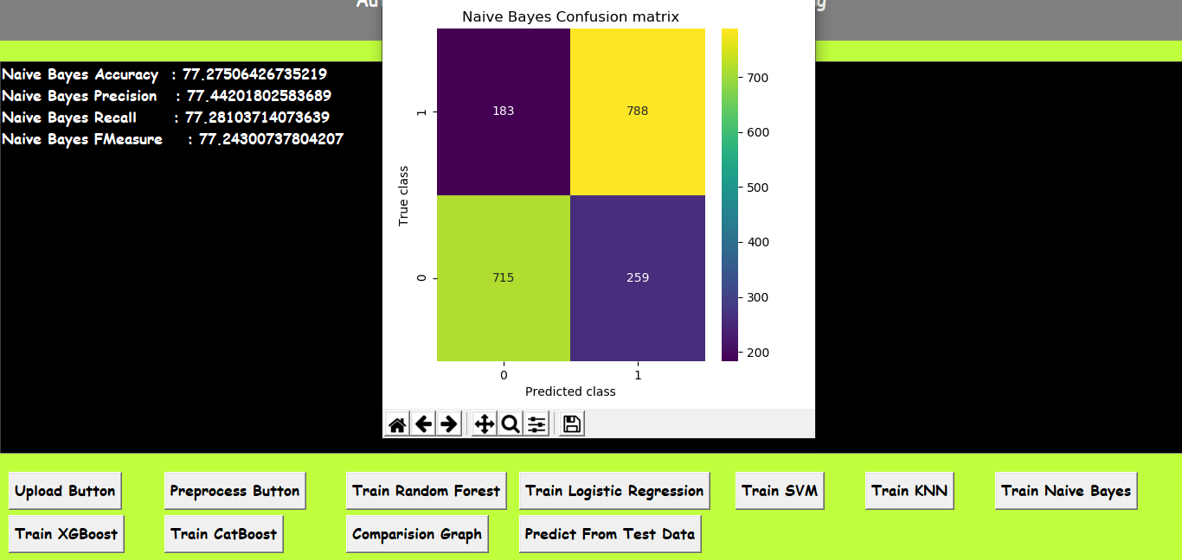
In above screen, click on Train Naïve Bayes button, to train Naïve Bayes and got 77% accuracy. In confusion matrix graph x-axis represents Predicted Labels and y-axis represents True Labels where blue boxes represents incorrect prediction count which are very few and yellow and light green boxes represents correct prediction count.

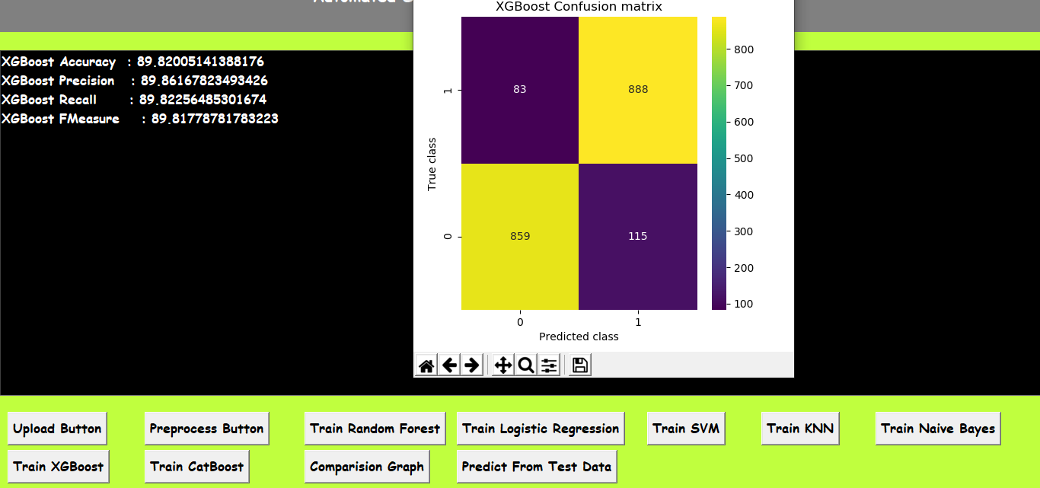
In above screen, click on XGBoost button, to train XGBoost and got 89% accuracy. In confusion matrix graph x-axis represents Predicted Labels and y-axis represents True Labels where blue boxes represents incorrect prediction count which are very few and yellow and light green boxes represents correct prediction count.

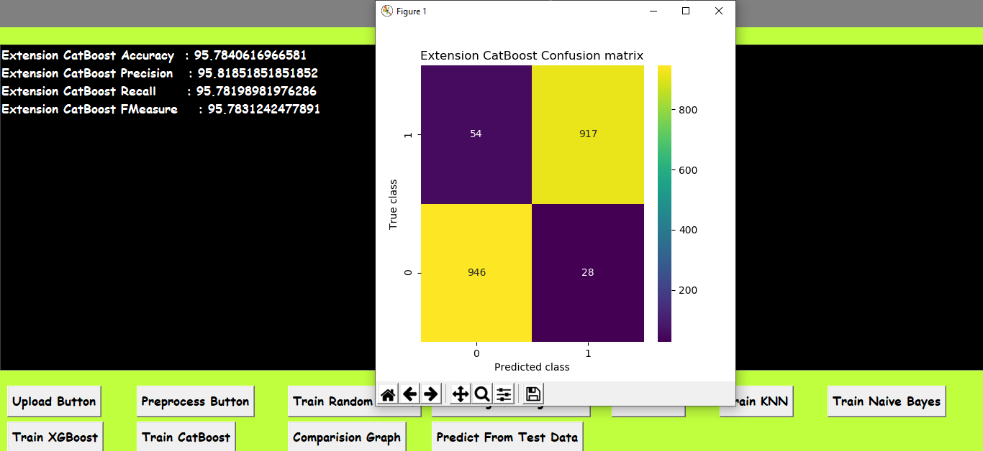
In above screen, click on Train CatBoost button, to train CatBoost and got 95% accuracy. In confusion matrix graph x-axis represents Predicted Labels and y-axis represents True Labels where blue boxes represents incorrect prediction count which are very few and yellow and light green boxes represents correct prediction count.

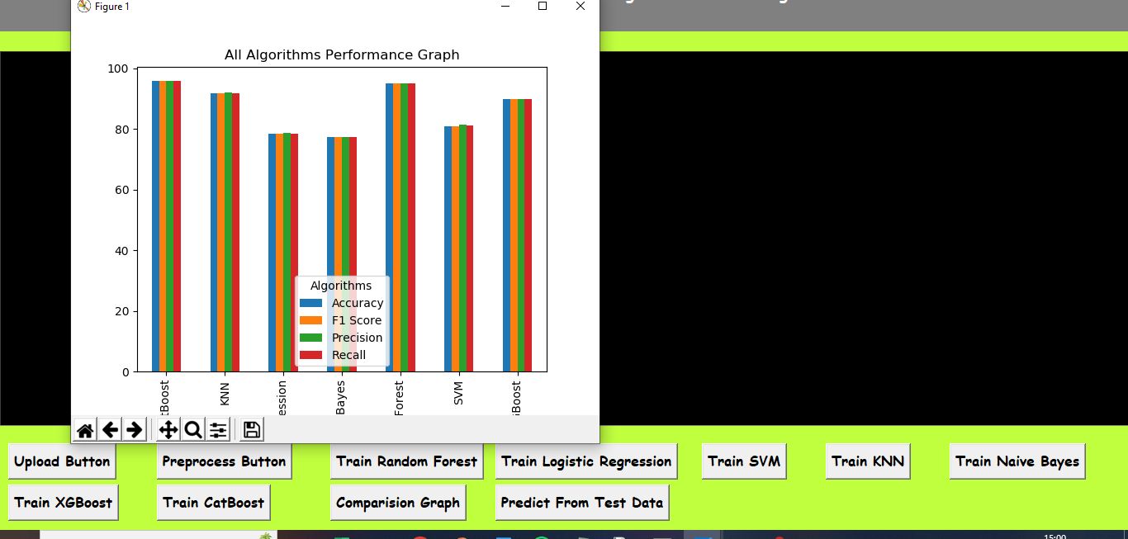
In above screen, click on comparision graph button, to compare all algorithms performance with four different parameters.
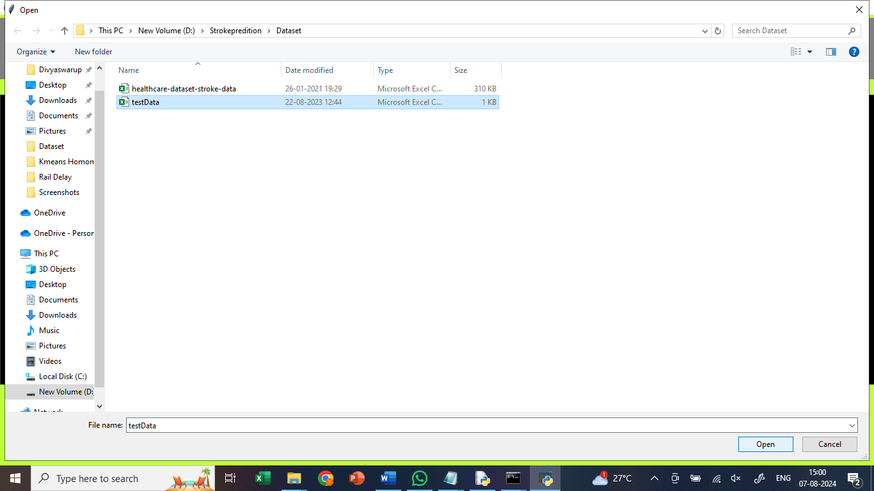
In above screen, click on predict from test data button, upload test data to predict whether data relates to stroke or normal
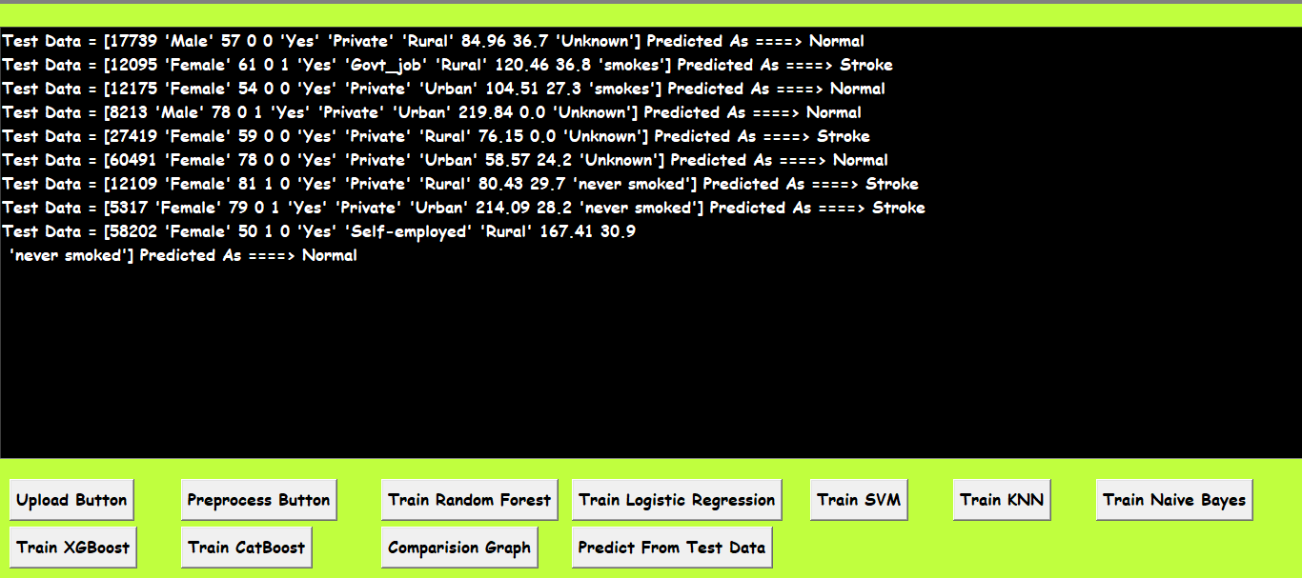
In above screen, after uploading test data, it classified data as normal or stroke.

8. CONCLUSION:
A clinical decision support system's Stroke Prediction can serve as a second option in Computer Aided Diagnosis. Although a large research community has helped, these AI based systems can only make predictions and cannot explain their rationale. This is where XAI approaches come in. We demonstrated how to approach Stroke Prediction in a domain-specific manner. For example, if a physician identifies as a Stoke patient but the model labels it as healthy, both the doctor and the patient may wonder "why?" Our method includes explanations such as "if the age of the patient is between 62 and 84, the prediction confidence in healthy diagnosis drops." The clinician may then notice the age limit in the electronic health records, which is not evident in the disease, and figure out why the model was predicted incorrectly. Whether the clinical decision support system supports or opposes the physician's diagnosis, offering human-readable reasons fosters confidence and improves system knowledge. Furthermore, our perturbation-based explanation technique for diagnosis employing medically relevant and irrelevant characteristics may have implications in other medical domains.

9. REFERENCES:

[1] Learn about Stroke. Available online: https://www.worldstroke. org/world-stroke-day-campaign/why-strokematters/ learnabout-stroke (accessed on 25 May 2022).

[2] Elloker, T.; Rhoda, A.J. The relationship between social support and participation in stroke: A systematic review. Afr. J. Disabil. 2018, 7, 1–9.

[3] Katan, M.; Luft, A. Global burden of stroke. In Seminars in Neurology; Thieme Medical Publishers: New York, NY,
USA, 2018; Volume 38, pp. 208–211.

[4] Bustamante, A.; Penalba, A.; Orset, C.; Azurmendi, L.; Llombart, V.; Simats, A.; Pecharroman, E.; Ventura, O.; Ribó,
M.; Vivien, D.; eta. Blood biomarkers to differentiate ischemic and hemorrhagic strokes. Neurology 2021, 96, e1928–e1939.

[5] Xia, X.; Yue, W.; Chao, B.; Li, M.; Cao, L.; Wang, L.; Shen, Y.; Li, X. Prevalence and risk factors of stroke in the elderly in Northern China: Data from the National Stroke Screening Survey. J. Neurol. 2019, 266, 1449–1458.

[6] Alloubani, A.; Saleh, A.; Abdelhafiz, I. Hypertension and diabetes mellitus as a predictive risk factor for stroke. Diabetes Metab.

[7] Syndr. Clin. Res. Rev. 2018, 12, 577–584. Boehme, A.K.; Esenwa, C.; Elkind, M.S. Stroke risk factors, genetics, and
prevention. Circ. Res. 2017, 120, 472–495.

[8] Mosley, I.; Nicol, M.; Donnan, G.; Patrick, I.; Dewey, H. Stroke symptoms and the decision to call for an ambulance. Stroke 2007, 38, 361–366.

[9] Lecouturier, J.; Murtagh, M.J.; Thomson, R.G.; Ford, G.A.; White, M.; Eccles, M.; Rodgers, H. Response to symptoms of stroke in the UK: A systematic review. BMC Health Serv. Res. 2010, 10, 1–9.

[10] Gibson, L.; Whiteley, W. The differential diagnosis of suspected stroke: A systematic review. J. R. Coll. Physicians Edinb. 2013, 43, 114–118.

[11] Murray, N.M.; Unberath, M.; Hager, G.D.; Hui, F.K. Artificial intelligence to diagnose ischemic stroke and identify large vessel occlusions: A systematic review. J. NeuroInterv. Surg. 2020, 12, 156–164.

[12] Zhao, Y.; Fu, S.; Bielinski, S.J.; A Decker, P.; Chamberlain, A.M.; Roger, V.L.; Liu, H.; Larson, N.B. Natural Language
Processing and Machine Learning for Identifying Incident Stroke from Electronic Health Records: Algorithm
Development and Validation. J. Med. Internet Res. 2021, 23, e22951.

[13] McDermott, B.J.; Elahi, A.; Santorelli, A.; O’Halloran, M.; Avery, J.; Porter, E. Multi-frequency symmetry difference
electrical impedance tomography with machine learning for human stroke diagnosis. Physiol. Meas. 2020, 41, 075010.

[14] Bivard, A.; Churilov, L.; Parsons, M. Artificial intelligence for decision support in acute stroke—Current roles and potential.
Nat. Rev. Neurol. 2020, 16, 575–585.

[15] Wang, W.; Kiik, M.; Peek, N.; Curcin, V.; Marshall, I.J.; Rudd, A.G.; Wang, Y.; Douiri, A.; Wolfe, C.D.; Bray, B. A
systematic review of machine learning models for predicting outcomes of stroke with structured data. PLoS ONE 2020, 15,
e0234722.

[16] Sirsat, M.S.; Fermé, E.; Câmara, J. Machine learning for brain stroke: A review. J. Stroke Cerebrovasc. Dis. 2020, 29,
105162.

[17] Arslan, A.K.; Colak, C.; Sarihan, M.E. Different medical data mining approaches-based prediction of ischemic stroke.
Comput. Methods Programs Biomed. 2016, 130, 87–92.

[18] Islam, M.S., Hussain, I., Rahman, M.M., Park, S.J. and Hossain, M.A., 2022. Explainable Artificial Intelligence
Model for Stroke Prediction Using EEG Signal. Sensors,22(24), p.9859.

[19] Dritsas, E. and Trigka, M., 2022. Stroke risk prediction with machine learning techniques. Sensors, 22(13), p.4670

[20] Kokkotis, C., Giarmatzis, G., Giannakou, E., Moustakidis, S., Tsatalas, T., Tsiptsios, D., Vadikolias, K. and Aggelousis, N.,
2022. An Explainable Machine Learning Pipeline for Stroke Prediction on Imbalanced Data. Diagnostics, 12(10), p.2392

